Headteacher: Mr Chris Marston BSc (Hons) PGCE NPQH
Elmwood Junior School, Lodge Road, Croydon, CR0 2PL
020 8684 4007 | admin@elmwood-jun.croydon.sch.uk | www.elmwood-jun.croydon.sch.uk

Friday 12th January 2024

Spring 1

Dear Parents/Carers,

Happy new year! We hope you had a great Christmas holiday and enjoyed spending some quality time together.

Our theme for this half term will be Ancient Discoveries. The children have started this week off by becoming archaeologists and exploring the ancient tomb of King Tutankhamun and throughout the curriculum, we will be exploring more about Ancient Egyptians and their impact on the world today.
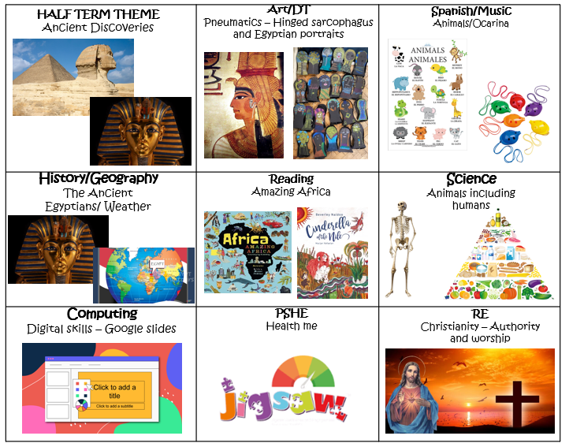
Theme:

In English and Reading our focus books will be:
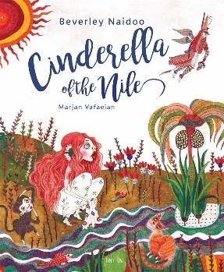
The children will be writing
- Narratives
- Non-chronological fact file

In Maths, the children will be learning about:
Multiplication and division – Multiply a 2-digit number by a 1-digit number with and without exchanges. Divide a 2-digit number by a 1-digit number.
Measurement and Length – Measure in millimetres, centimetres and metres; compare and add lengths and find equivalent lengths.
Perimeter – Understand what perimeter is and measure and calculate the perimeter.

Homework changes:
We will now set the Mathletics and the comprehension homework every Monday. This will give children the whole week to complete their tasks.
Daily  Reading for 15 minutes | Monday  Mathletics  And Google comprehension set | Friday  Spelling | *New*  Half Termly  A project will be set for the children based around the topic they will be learning at school.

Dates for your diary:

Event | Date
British Museum Trip 3S and 3B | Friday 12th January 2024
British Museum Trip 3R and 3C | Thursday 25th January 2024
Swimming | Every Wednesday
George Knowland Day | Wednesday 31st January 2024
Legacy Hair Day | Friday 9th February 2024

Swimming:

Now that we have started swimming, please could you also ensure that your child’s clothing is clearly labelled with their name and class.

As always, thank you for all your support over the last term.

Best wishes,

The Year 3 team

