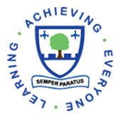

Life-Long Learners

Add photo

Hi my name is _________
I attended Elmwood Junior School _____ years ago.
I am now a _______________

My favourite subject at Elmwood was_________ because ________.
Add an inspiring quote/message for pupils that helped you get to where you are.
______________________________

