ELMWOOD
JUNIOR SCHOOL

SAFEGUARDING AND CHILD PROTECTION POLICY

Issue 9

SAFEGUARDING AND CHILD PROTECTION POLICY

We at Elmwood Junior School are committed to safeguarding and promoting the welfare of children and young people and expect all staff, volunteers and third parties to share this commitment.
The safety of our pupils is our number one priority. Any concerns or signs of abuse or neglect must be reported immediately to one of our Designated Safeguarding Leads (DSL)

School Contacts
Designated Safeguarding Lead (DSL) Mrs D Devecioglu Assistant Head Teacher
Elmwood Junior School 020 8684 4007
Deputy Safeguarding Leads Mrs A Read Head Teacher
Mr D Beck Deputy Head Teacher
Mrs J Kriesler Assistant Head Teacher
Mrs H Henfrey Year Leader & ICT Coordinator
Mrs P Macleod Pupil Welfare and Data Manager
Elmwood Junior School 020 8684 4007

Chair of Governors Mr P Dancy
Named Governor with responsibility for safeguarding Mr P Dancy

Local Authority (LA) Contacts
The Local Authority Designated Officer for Child Protection (LADO)
The LADO is the contact person for Head Teachers or Chair of Governors when there is a concern or allegation that a staff member or volunteer has behaved in a way that has harmed a child, or may have harmed a child, or possibly committed a criminal offence against or related to a child or behaved towards a child in a way that indicates that they are unsuitable to work with children.

Steve Hall / Jane Parr
LADO@croydon.gov.uk 020 8255 2889
Bernard Weatherill House
6 Mint Walk
Croydon CRO 1EA

For general child protection, safeguarding advice or to check if a child has a Child Protection Plan: The Children’s Quality Assurance and Safeguarding Service (CQASS) offers child protection advice in relation to practice and policy within Croydon and in respect of the London Child Protection Procedures. The CQASS is also responsible for the reviewing of children subject to Child Protection Plans and Children Looked After. Requests for information about these children can be made to CQASS 020 8726 6400 and ask to speak to one of the managers or contact childreferrals@croydon.gov.uk
For advice about whether a safeguarding referral is appropriate please ring the Local Authority Consultation line 020 8726 6464

Where there is a risk of immediate serious harm to a child, the police should be called immediately and a referral should be made to children’s social care. Anybody can make a referral. Please call 020 8726 6400
Out of hours 0208 726 6000 (listen to the whole of the message and hang on for the emergency response) A social work service is available between 5pm and 8.30am Monday to Friday and during weekend hours.
Always follow up telephone calls in writing within 24hrs.
Local authority on line referrals SPOC (Single Point of Contact) www.croydon.gov.uk then click on worried about a Croydon child
Or e-mail childreferrals@croydon.gov.uk
For further advice and guidance: croydonhr.co.uk/safeguarding
Our school follows the safeguarding protocols and procedures of the Croydon Safeguarding Children Board (CSCB) croydonlcsb.org.uk

Local Police Emergency 999
Local Police non-emergency 101
Location of safeguarding concern forms in school: The School Office or online Teachershare/Safeguarding/ Documents 2016
National Contacts
Child Line 0800 11 11
NSPCC Help Line 0808 800 5000 help@nspcc.org.uk

INDEX

Page
1. Introduction 4
2. Overall aims 4
3. Key Principles 5
4. Roles and Responsibilities 5
5. What to do if you are concerned that a child is being abused 8
6. How to respond to a child telling you about abuse 10
7. Allegations against a Member of Staff, Governor or Volunteer 10
8. Confidentiality and Information Sharing 12
9. Safer Recruitment & Selection 12
10. Creating a Child Protective Environment 13
11. Working with Parents and Carers 15
12. Children with Special Educational Needs and Disabilities (SEND) 15
13. Signs and Indicators of Abuse 16
14. Specific Safeguarding Issues 19
15. Data Protection 25
APPENDICES
Appendix 1 A summary of the UN convention on the rights of the child 26
Appendix 2 Actions where there are concerns about a child 27
Appendix 3 Cause for Concern Form 28
Appendix 4 Body Map and Guidance (for use with Appendix 2) 29
Appendix 5 Safeguarding File log 33
Appendix 6 Record of Actions 34
Appendix 7 Transfer of Safeguarding Child Protection Information to other schools 35
Appendix 8 List of Contacts 36

INTRODUCTION

CHILD PROTECTION POLICY STATEMENT

We, at Elmwood Junior School, believe that it is always unacceptable for a child or young person to experience abuse of any kind and recognise our responsibility to safeguard the welfare of all children and young people, by a commitment to practice that protects them. At the school we are committed to ensuring that the articles within the UNCRC are adhered to. The Governors expect all staff and volunteers to share this commitment by demonstrating their understanding of how each individual adult working on behalf of the school has an active part to play in protecting children from harm and promoting their welfare so maintaining an ethos where all adults in the school community are vigilant and “look out” for children. We recognise that:-

- The welfare of the child is paramount;
- Children need to be safe and to feel safe in school (article 19);
- All children, regardless of age, disability, sex, gender identity, racial heritage, religious belief, sexual orientation or identity, have the right to equal protection from all types of harm or abuse (article 2);
- Working in partnership with children, young people, their parents and carers and other agencies is essential in promoting young people’s welfare;
- All children have the right to speak freely and voice their values and beliefs (article 12);
- All children must be encouraged to respect each other’s values and support each other (article 12);
- All children have the right to be supported to meet their emotional, and social needs as well as their educational needs – a happy, healthy, sociable child will achieve better educationally (article 29);
- Schools can and do contribute to the prevention of abuse, victimisation, bullying, exploitation, extreme behaviours, discriminatory views and risk taking behaviours (article 19);
- All staff and visitors have an important role to play in safeguarding children and protecting them from abuse (article 19).

1.1 Safeguarding is defined as:-

- Protecting children from maltreatment;
- Preventing impairment of children's health or development;
- Ensuring that children are growing up in circumstances consistent with the provision of safe and effective care; and
- Taking action to enable all children to have the best life chances.

1.2 Elmwood Junior School will fulfil its local and national responsibilities as laid out in the following documents:-

The most recent version of: Working Together to Safeguard Children (DfE) July 2018;
- The most recent version of; Keeping Children Safe in Education: Statutory guidance for schools and colleges (DfE) September 2019;
- What to do if you are worried a child is being abused. Advice for practitioners (9DfE) March 2015;
- The Procedures of Croydon Safeguarding Children Board;

The Education Act 2002 s175/s157;

Mental Health and Behaviour in Schools: Departmental Advice (DfE) March 2016;
- Guidance for Safer Working Practice for Adults who work with Children and Young People in Education Settings (DfE) March 2015.
- Offensive Weapons Guidance for Education Providers (Croydon 2017)
- Sexual Violence and Sexual Harassment between Children in Schools and Colleges (DfE May 2018)

OVERALL AIMS

2.1 The aims of this policy are to:-

- To provide protection for the pupils;
- To provide staff and volunteers with guidance on procedures they should adopt in the event that they suspect a child or young person may be experiencing, or be at risk of harm;
- Alert staff to the signs and indicators that all might not be well;
- Develop staff awareness of the causes of abuse;
- Develop staff awareness of the risks and vulnerabilities their pupils face;
- Address concerns at the earliest possible stage;
- Reduce the potential risks pupils face of being exposed to violence, extremism, exploitation or victimisation;
- Emphasise the need for good levels of communication and that safeguarding is everybody’s responsibility.

All staff at Elmwood Junior School recognise that a range of other school policies are central to many aspects of the school’s Child Protection Policy, and this document should therefore be read in conjunction with our policies and procedures for:-

Anti-bullying
Attendance
Behaviour
Complaints
Disclosure & Barring Services
E-safety
Equal Opportunities
Health and Safety
Inclusion
Looked After Children
Personal, Social, Health & Economic Education Citizenship (PSHEEC)
Staff Code of Conduct
Supporting Pupils with Medical Conditions
Special Educational Needs and Disability
Whistleblowing

3. KEY PRINCIPLES

At Elmwood Junior School we regard the safeguarding of pupils to be paramount. It underpins everything we do. Staff are advised to maintain an attitude of “it could happen here” where safeguarding is concerned and play their part in creating a culture of vigilance and an environment in which pupils feel comfortable to speak about their worries and concerns and be confident that they will be listened to, taken seriously and responded to appropriately.

Staff members will always act in the best interests of its pupils. The nature of day to day relationships between pupils and staff enables all adults working in the School to be particularly well-placed to notice any physical, emotional or behavioural signs that a child may be suffering significant harm or to provide a listening ear.

Ultimately, effective safeguarding of children can only be achieved by putting children at the centre of the system and by every individual and agency playing their full part. We recognise that it is essential to work in partnership with pupils, their parents and carers and other agencies in order to promote pupils’ welfare.

4. ROLES AND RESPONSIBILITIES

4.1 GOVERNING BODY

- Will ensure that a member of the Governing Body is nominated to liaise with the LA and/or partner agencies on issues of child protection and in the event of allegations of abuse made against the Head Teacher, or member of the Governing Body. The Governing Body should ensure that there are procedures in place to handle allegations against teachers, the head teacher, volunteers or other members of staff. (Keeping Children Safe in Education September 2019 – Part 4);

- Will ensure that there are appropriate policies and procedures in place in order for appropriate action to be taken in a timely manner. This includes a Staff Code of Conduct and an effective child protection policy that complies with current legislation and the Croydon Safeguarding Children Board (CSCB). All such policies and procedures will be reviewed annually and made available to parents;

- Will ensure that the School operates safer recruitment procedures and makes appropriate staff and volunteer checks which deter, reject or identify people who may abuse children (Keeping Children Safe in Education September 2019 – Part 3);

- Will ensure that at least one member of an appointing panel will have attended safer recruitment training;

- Will ensure that the School has a Designated Safeguarding Lead Person (DSL) for child protection who is a member of the school’s Senior Management Team. This should be explicit in the role holder’s job description. They will also ensure that a designated teacher is appointed to promote the educational achievement of children who are looked after. (See Children Looked After Policy);

- Will ensure that the School contributes to multi-agency working in line with statutory guidance (Working Together to Safeguard Children);

- Will ensure that the School keeps an up to date single central record;

- Recognise the importance of information sharing between professionals and local agencies;

- Monitor the adequacy of resources committed to child protection and the effectiveness of the policy and procedures and address any shortcomings in a timely manner;

- Will ensure that all staff undergo safeguarding and child protection training at induction and receive regular updates to provide them with the knowledge and skills to safeguard children effectively and that mechanisms are in place for all staff to contribute to and shape child protection policy;

- Will ensure that appropriate filters and monitoring systems are in place to protect children from inappropriate and harmful online material;

- Will ensure that the curriculum provides opportunities for children to learn about risks and how to keep themselves safe.

4.2 HEAD TEACHER

- Will ensure that policies and procedures adopted by the Governing Body are followed by all staff;

- Will appoint a member of staff to be the Designated Safeguarding Lead Person;

- Will ensure that sufficient resources and time are allocated to the designated persons and other staff to discharge their responsibilities including taking part in strategy discussions and other multi-agency meetings, to contribute to the assessment and support of children and be appropriately trained;

- Will ensure that all staff feel able to raise concerns about poor or unsafe practice and that such concerns are handled sensitively, in a timely manner and in accordance with the school’s whistle blowing procedures.

  - DESIGNATED SAFEGUARDING LEAD (DSL)

- Will know about the signs and symptoms of abuse and how abusers behave;

- Will ensure that the school’s Safeguarding and Child Protection Policy and procedures are followed, reviewed and updated;

- Will ensure that information is shared appropriately;

- Will refer cases of suspected abuse to social services and liaise with the Head Teacher and other agencies in accordance with LA procedures as required;

- Will manage referrals to outside agencies including the Police, the Channel programme, the Disclosure and Barring Service and Early Help;

- Will support staff and act as a source of expertise and advice to the school community regarding safeguarding matters;

- Will undertake training (including Prevent) in order to have the knowledge and skills to carry out the role. This training to be up dated at least every two years. In addition to this formal training, the DSL should keep abreast of current developments and update their knowledge and skills at regular intervals, but at least termly, by attending LA safeguarding forums and attending courses about specific safeguarding issues;

- Will ensure that all staff members receive appropriate safeguarding and child protection and that they are regularly updated at least annually with the knowledge and skills required to safeguard children effectively;

- Will understand and support the school with regards to the requirements of the Prevent duty and know about how to refer to cases to the Channel programme;

- Will refer cases where a person is dismissed or leaves due to risk/harm to a child to the Disclosure and Barring Service as required and refer cases to the Police where a crime may have been committed;

- Will contact the LADO where there are concerns about adults working in the school including the Head Teacher;

- Will ensure that all adults working in the School, including supply teachers, visiting professionals working with pupils and volunteers are informed of the names and contact details of the designated leads and the school’s procedures for safeguarding children;

- Will attend or arrange for an appropriate member of staff to attend strategy meetings and case conferences and will co-ordinate the school’s contribution to these;

- Will ensure that when a child on the Child Protection register leaves the school, the DSL of the receiving school is contacted and that records are passed onto the new school as soon as possible but separately from the main pupil file. The pupil’s social worker should also be informed where the pupil is transferring to a school in another authority, Social/Children’s Services within the new authority should be contacted for advice on where to send the records;

- Will ensure that detailed, accurate and secure written records of concerns and referrals are kept;

- Will ensure that all child protection records are marked as such and kept securely locked and separate from other pupil records and any electronically stored records are accessible only by the Head Teacher/Designated Leads;

- Will ensure that Pupil School Records (PSRs) are marked to indicate that the pupil has a further safeguarding file;

- Will monitor attendance and inform social services if there are concerns over the attendance of a pupil who has a child protection plan;

- Will ensure that information is shared appropriately;

- Will undertake an annual LA safeguarding audit, share with designated governor and address any points for improvement;

- Will ensure that all stakeholders including pupils have an opportunity to shape policy;

- Will inform parents of the School’s responsibilities with regard to child protection procedures and make the policy available to them;

- Will work with the Governing Body and keep them abreast of safeguarding issues in the School, report on the effectiveness of the School’s safeguarding procedures and bring their attention to any deficiencies.

4.4 STAFF

All staff, teaching and non-teaching, in the School need to:-

- Be aware of the systems in place in the School which support safeguarding. This includes reading and understanding the Safeguarding and Child Protection Policy, adhering to the Staff Code of Conduct, knowing who the designated person and the deputies are and knowing what and how to record concerns;

- Read “Keeping Children Safe in Education – Part 1” September 2019;

- Be aware that to safeguard children, they have a duty to share information with the DSL and with other agencies;

- Know that they can make their own referral to social care and know how to do this;

- Be alert to signs and symptoms of harm and abuse;

- Know how to respond should a child make a disclosure;

- Receive appropriate safeguarding and child protection training which is regularly updated but at least annually, to provide them with the relevant skills and knowledge to safeguard children effectively;

- Actively listen to children and maintain an attitude of “it could happen here”;

- Support children in understanding how they can keep themselves safe;

- Provide information for multi-agency meetings and attend themselves where necessary and act upon any recommendations resulting from such a meeting;

- Be aware of the early help process and understand their role in it;

- Act in the best interests of the child when they have concerns.

5. WHAT TO DO IF YOU ARE CONCERNED THAT A CHILD IS BEING ABUSED

All children at Elmwood Junior School must be able to place their trust and confidence in any adult working in the School. They must feel sure that they can speak about any worries or concerns they may have and that they will be listened to, taken seriously and responded to appropriately. All staff must therefore know what to do if a child chooses to talk to them about any matter which raises child protection concerns. All staff members should be aware of the signs of abuse and neglect so that they are able to identify cases where children may be in need of help or protection. Knowing what to look for is vital to the early identification of abuse or neglect. If staff members are unsure, they should always speak to the DSL or social care.

RESPONDING TO PATTERNS OF CONCERN

  - All concerns about children’s welfare should be recorded and given to the DSL. The DSL will decide if concerns warrant a referral to social care. Normally the DSL will speak to parents about concerns before a referral is made and ask the parents for their explanation of the concerns and tell them that a referral Croydon’s Single Point of Contact (SPOC) is going to be made.
Normally the DSL will speak to parents before a referral is made explaining why however, parents will not be informed about concerns where, in the opinion of the school, it would jeopardise the child’s safety. All adults working with pupils at the School have a duty to act on child welfare concerns and their anonymity cannot be preserved.

  - Early Help Pathways

Sometimes a child may have additional needs, which require a coordinated approach from the agencies involved, without the need to refer to MASH. (Multi Agency Safeguarding Hub)
Working Together to Safeguard Children (2013) sets out a clear expectation that local agencies will work together and collaborate to identify those children with additional needs and provide support as soon as a problem emerges. Providing early help is far more effective in promoting the welfare of children – and keeping them safe – than reacting later, when any problems, for example neglect, may have become more entrenched.

Any child may benefit from early help, but all school staff should be particularly alert to the potential need for early help for a child who:
- is disabled and has specific additional needs;
- has special educational needs (whether or not they have an EHCP);
- is a young carer;
- is frequently missing/goes missing from care or home;
- is misusing drugs or alcohol;
- is in a family circumstance presenting challenges for the child, such as substance abuse, adult mental health problems or domestic abuse;
- has returned to their family from care.

All staff may be involved in working with outside agencies at this stage to provide support. However, a referral to children’s social care should take place if the child’s situation does not seem to be improving and the case should be kept under constant review and a referral to children’s social care made if the child’s situation does not appear to be improving. All services which are provided must be based on a clear understanding of the needs and the views of the individual child in their family and community context.
Details of the services available and how they can be accessed are available online at:

https://croydonlcsb.org.uk/

  - Single Point of Contact

The Single Point of Contact is the LA’s ‘front door’ to manage all safeguarding referrals and to consider the most appropriate support available for families in need of help. Whether a safeguarding or early help response is needed, the Single Point of Contact should be contacted. The Single Point of Contact is made up of staff from the Multi-Agency Safeguarding Hub (MASH) and Early Help. The MASH team is made up of: Children’s Social Care, Police Public Protection Desk, Health, Education, Youth Offending Service, Early Help and Youth Services, Probation and Housing. MASH operates a safeguarding consultation line to provide safeguarding advice and consultation to professionals who would like to discuss the concerns they may have about a child/family. This is for safeguarding advice only. The contact number for the safeguarding consultation line is 020 8726 6464. For all other enquiries use 020 8726 6400.

5.4 Recording

When staff become aware of possible abuse, they must make full written record as soon as possible and always within 24 hours of the situation arising. This may be recorded directly onto a Single Point of Contact / MASH Online Referral (making sure that a copy is printed to keep on the child’s records), or if there is a lot of detail, be recorded on the Child Protection Cause for Concern form (see appendix 3). All recordings should be passed to the DSL or a Safeguarding Deputy.

Recording should include as many of the following details as you know:-

- Index details of the child, and if known, their family, or carers, alleged offenders, witnesses, other involved children. Index details are names, dates of birth, addresses, sex;
- As much information as possible about the incident of concern i.e. what lead up to it, what was heard or witnessed, staff member’s responses, location of the event, date, time and details of anyone present;
- Any action taken by the member of staff as a result of the incident;
- Other relevant background information.

When you record:-

- Distinguish between fact and opinion;
- Try to describe what happened fully but succinctly;
- Make the recording legible;
- Sign and date the recording and ensure your name and designation are clearly typed or printed;
- Physical injuries should be recorded on a body map;
- You should record only what you can see without removing additional clothing.

All records of child protection issues will be kept in a central, lockable, non-portable cabinet.

5.5 Referral Time Scales

Referrals following specific incidents should be made within 24 hours. Where concern has built over a period of time, referral may be delayed. Referrals should normally be made by the Designated Safeguarding Lead, however a referral may be made by any member of staff if necessary.

  - Emergencies

- If you believe a child is in immediate physical danger you should call the Police on 999.
- If a child is injured or showing signs of illness, you should seek medical assistance and try to contact the child’s carers, who will normally be able to consent to treatment. Depending on your degree of concern you may want to contact the London Ambulance Service immediately.
- It is your responsibility to access help and try to access the child’s parent or carer, not to determine consent issues.

  - Disagreements about the Need for Referral

If staff and managers disagree about the need for a referral, they should seek advice. If the matter cannot be resolved, statutory guidance states that members of staff can make a referral without the consent of their manager.

  - Dissatisfaction with the Response to Referral

If you are dissatisfied with the outcome of your referral and particularly if you are concerned that a child may be left at risk, you must ask to talk to either the Assistant/Unit Manager within MASH.

6. HOW TO RESPOND TO A CHILD TELLING YOU ABOUT ABUSE

Sometimes you will be concerned about abuse because of what a child says to you. If this happens you should:-

- Stay calm and reassuring. Respond with tact and sensitivity and do not make judgements;
- Find a quiet place to talk and allow the child to speak in their own time (this should still be in the open, but away from the crowd and you should tell somewhere else where you are going and with whom);
- Believe in what you are being told; take allegations or suspicion of abuse seriously;
- Listen, possibly confirm details but do not press for information or ask leading questions as this may void any disclosure you receive in a court case or investigation;
- Make brief notes using the person’s own words. Do not interpret what has been said or make assumptions;
- Say that you are glad that the child told you;
- Acknowledge that the child may have angry, sad or even guilty feelings about what happened, but stress that the abuse was not the child's fault;
- If necessary, seek medical help and contact the police or social services;
- Ensure the safety of the child and that they are away from the alleged abuser;
- Follow procedures for reporting allegations and suspicions to the DSL.

Do not:-

- Promise confidentiality, but do discuss with the child who you need to tell;
- Investigate the allegation yourself and do not contact the parents/carers until advised to do so by the Local Authority/officer in charge of the allegation;
- If it will help the child to cope say that the abuser has a problem;
- Say that you will do your best to protect and support the child.

Acknowledge to yourself:-

That you may need help dealing with your own feelings and your employer/organisation should provide additional support this could include a follow up session, time off or counselling.

7. ALLEGATIONS AGAINST A MEMBER OF STAFF, GOVERNOR OR VOLUNTEER

It is essential that any allegation of abuse made against a member of staff, governor or volunteer is dealt with fairly, quickly, and consistently, in a way that provides effective protection for the child and at the same time supports the person who is the subject of the allegation.

7.1 What Is Meant By an Allegation Against A Member of Staff

You should be concerned if you believe that a member of staff has:-

- Behaved in a way that has harmed a child, or may have harmed a child;
- Possibly committed a criminal offence against or related to a child;
- Behaved towards a child or children in a way that indicates they are unsuitable to work with children.

7.2 This part of the guidance applies whether the child is someone with whom the member of staff is acquainted through their work, is a family member, friend, or stranger. As well as the safety and wellbeing of the subject child and other involved children, it is important to consider the staff member’s long term attitude, access and level of risk to children.

7.3 This part of the guidance applies to all staff whether the member of staff is paid, a volunteer, a permanent, or an agency member of staff. It includes anyone who has access to children, or data about them.

7.4 Role of the LADO

Where there is reason to suspect that the individual of concern may be unsuitable to work with children, the matter must be reported to the Local Authority Designated Officer, who will decide where the threshold for investigation under Child Protection procedures is met and will make arrangements to co-ordinate activity. Once it is clear that the individual should be referred, this should occur without delay, so that an agreement can be made about immediate action and what information can and cannot be shared.

The Croydon LADO is:-

Steve Hall / Jane Parr
Telephone Number: 020 8255 2889
E-Mail: LADO@croydon.gov.uk
Location: 4th Floor, Bernard Weatherill House, 8 Mint Walk, Croydon, CR0 1EA

7.5 Action

If you are concerned that a member of staff may have abused a child you must:-

- Ensure that the child or young person is safe;
- Make a written note of the concerns ensuring names and times are clearly recorded. Do not speak to the child, young person or the member of staff in respect of the allegation;
- Talk immediately to the Designated Safeguarding Lead person and decide who is going to discuss the matter with the LADO;
- If your concern relates to the Designated Safeguarding Lead person, discuss with the LADO in Children’s Quality Assurance immediately;
- Where a member of staff has obviously assaulted a child or young person, the Police should be informed.

In deciding whether to take immediate action in respect of the member of staff against whom the allegation was made, it will be necessary to balance any ongoing risks to children, against the risks of alerting the member of staff in such a way that they may silence children, or destroy evidence.

7.6 A member of staff may be suspended with immediate effect by their manager if there are grounds for concern. However, the LADO should be consulted before action is taken.

7.7 What Happens After Referral

Following referral to the Contact Centre, the assessments team will forward the matter to Children’s Quality Assurance, who will:

- Undertake checks on those involved;
- Decide whether a multi agency Allegations Strategy Meeting is required;
- If a multi agency meeting is required, convene it, normally within 2 working days;
- Provide advice and guidance to employers;
- Track the different processes to their conclusion including any criminal investigation.

7.8 Management Oversight and Support

Management oversight and support is vital to sound safeguarding and child protection practice. The aim is that the line manager/DSL helps the professional to reflect on their work with the child about whom there are child protection concerns and their family. It is important that the line manager/DSL is able to:-

- Relate child protection procedures and what works in child protection practice to the particular case;
- Help the professional think about the way in which the relationships between the child the family and the professional group, affect them and their work;
- Challenge and check current practices and procedures around safeguarding within the organisation.

8. CONFIDENTIALITY & INFORMATION SHARING

8.1 Information may be shared to protect a child or vulnerable person, or to prevent a crime. Early sharing of information is the key to providing effective early help where there are emerging problems. The Data Protection Act is not a barrier to sharing information, but provides a framework to ensure that personal information about living persons is shared appropriately.

8.2 When working with children, guarantees of absolute confidentiality must not be given. Those working with children should tell them that information will be shared if it is necessary to keep a child or vulnerable adult safe.

8.3 Staff should be open and honest with the child (and their family where appropriate) from the outset about why, what, how and with whom information will, or could be shared, and seek their agreement, unless it is unsafe or inappropriate to do so.

8.4 Staff should seek advice if they are in any doubt. Fears about information sharing cannot be allowed to stand in the way of the need to promote the welfare and protect the safety of children.

8.5 Staff should follow the normal rules for safe data storage and transfer.

8.6 Recording should include the decision and the reasons for it – whether it is to share information or not. It should include what was shared, with whom and for what purpose.

8.7 It is important that professionals work together to get a full picture of need so that the child can get the appropriate help. Everyone who comes into contact with them has a role to play in identifying concerns, sharing information and taking prompt action.

9. SAFER RECRUITMENT AND SELECTION

9.1 Staff and volunteers will be selected based on their suitability to the role. All staff/volunteers are required to complete the recruitment process before activity commences. The School pays full regard to ‘Keeping Children Safe in Education’. Safer recruitment practice includes scrutinising applicants, verifying identity and academic or vocational qualifications, obtaining professional and character references, checking previous employment history and ensuring that a candidate has the health and physical capacity for the job. It also includes undertaking interviews and undertaking appropriate checks through the Disclosure and Barring Service (DBS).

9.2 All recruitment materials will include reference to the School’s commitment to safeguarding and promoting the wellbeing of pupils. Job descriptions and personal specifications will be made for each new role/position and agreed with the governing body.

9.3 Staff’s ability to deal with disclosures should be assessed. Mrs A Read ( Head Teacher), Mr D Beck (Deputy Head Teacher), Mrs S Wilcox (School Business Manager), and Mr P Dancy and Mrs S Ramsbotham (Chair and Vice Chair of the Governing Body) have undertaken appropriate training in Safer Recruitment. One of the above will be involved in all staff recruitment processes and sit on the recruitment panel.

  - All staff will be required to:-

- Complete an application form;
- Provide proof of identity and qualifications;
- Provide two references who may be contacted before interview;
- Attend an interview, with at least two interviewers;
- Explain gaps in employment;
- Complete a self-disclosure form;
- Obtain an enhanced disclosure through checks from the Disclosure and Barring Service (DBS) (when they will be in contact with children, both directly and indirectly);
- Complete an agreed probationary period;
- Undertake induction and training.

9.5 When appointing new staff, the School will:-

- Verify a candidate’s identity, preferably from current photographic ID and proof of address except where, for exceptional reasons, none is available;
- Obtain a certificate for an enhanced DBS check with a barred list information where the person will be engaging in regulated activity;
- Obtain a separate barred list check if an individual will start work in regulated activity before the DBS certificate is available;
- Check that a candidate to be employed as a teacher is not subject to a prohibition order issued by the Secretary of State, using the Employer Access Online service;
- Verify the candidate’s mental and physical fitness to carry out their work responsibilities. A job applicant can be asked relevant questions about disability and health in order to establish whether they have the physical and mental capacity for the specific role;
- Verify the person’s right to work in the UK. If there is uncertainty about whether an individual needs permission to work in the UK, then prospective employers, or volunteer managers, should follow advice on the GOV.UK website;
- If the person has lived or worked outside the UK, make any further checks the school considers appropriate;
- Verify professional qualifications, as appropriate.

9.6 It is important to remember that as well as putting children and staff at risk, if a school or college knows or has reason to believe that an individual is barred, it commits an offence if it allows the individual to carry out any form of regulated activity. There are penalties of up to five years in prison if a barred individual is convicted of attempting to engage or engaging in such work.

9.7 Any applicant refusing to go through the vetting and barring system or DBS check will not be employed as a paid member of staff or as a volunteer if their role includes regulated or (and currently) controlled activities that require registration. Current definitions of controlled and regulated activity can be found on the DBS website.

9.8 All staff and volunteers will go through DBS checks as necessary. All staff/volunteers who have regular, unsupervised access to children or vulnerable adults will need a DBS check as will the designated person for child protection. Staff/volunteers who have regular contact with children and young people through mixed groups (activities that both adults and children participate in together), and who have positions of responsibility and trust where contact with children is possible will also need a DBS check.

9.9 All governors be subject to identity checks and an enhanced DBS check which will obtained within 21 days of their appointment as a governor. If a governor has no contact with children, a DBS without a barred list check is acceptable. All governors’ sign a declaration that they are not disqualified from acting as a governor, for one of the reasons prescribed by legislation. A person prohibited under section 128 is also disqualified from holding or continuing to hold office as a governor of a maintained school. A section 128 check will be obtained by the school for each new governor and will be re-checked annually.

10. CREATING A CHILD PROTECTIVE ENVIRONMENT

At Elmwood we believe that children are best protected in an environment where all aspects of their welfare are taken into account and where there is proper planning for events and activities.

10.1 Attendance

We are aware that a pupil’s unexplained absence from school could mean that they are at risk from harm.

- We will always report an unexplained absence of a child with a Child Protection Plan to the child’s social worker within one day;

- We will always seek to clarify the reason for a child’s absence from school with the child’s parent or carer as soon as is practicable on the first day;

- We will always report a continued absence about which we have not been notified by the parent or carer to the Education Welfare Service;

- We will always report to the local authority the name of any child who has been newly registered to attend our school but does not arrive on the expected day;

- We will always report to the Education Welfare Service the continued absence of a child known or thought to have been taken overseas if the child does not return to school on the expected return date.

  - Curriculum

The Personal, Social, Health & Economic & Citizenship scheme of work provides opportunities in the curriculum for pupils to learn about aspects of safeguarding including E-safety. Topics covered include decision making, assertiveness and support networks, cyber bullying and taking risks. During these lessons opportunities will be provided for pupils to develop skills, concepts, attitudes and knowledge that promote their safety and well-being. The Dot Com journals also provide age appropriate opportunities for discussion of specific safeguarding topics e.g. domestic violence as well as providing the means for disclosures. Assemblies and Circle Time are used to remind pupils about aspects of safety, e-safety and site security. Pupils are encouraged to tell somebody if they ae worried about anything and the “listening” ethos of the school is emphasised.

All classes will have a “worry box” where pupils can anonymously write about anything that is troubling them.

All pupils are taught the number of Childline and know that there is a telephone in school which they can use confidentially.

Relevant issues will be addressed through other areas of the curriculum, for example, Circle Time, English, History, Drama, Art, etc.

Visits and visitors from outside agencies such as the Police and the NSPCC are welcomed into school and play an important part in helping pupils to know how to keep themselves safe. Each year four agencies provide a Citizenship Day for Year 6 pupils.

  - Rights Respecting

At Elmwood Junior School we are always trying to introduce new initiatives to improve pupil well-being. Although our pupils have opportunities to make informed choices that contribute to their learning, we are of the view that making them aware of their rights and embedding the United Nations Convention on the Right of the Child (UNCRC) will boost their confidence and self-esteem when participating in decision-making activities. See appendix 1.

10.4 E-Safety

We recognise that children’s use of the Internet is an important part of their education, but that there are risks of harm associated with its use. We have a Computing Policy and E-Safety Policy which address how we minimise those risks in school and teach children how to stay safe when using the internet in their lives out of school.

We also recognise that all members of staff, volunteers parents and governors must always be mindful of the need to follow our policy of acceptable use of our IT equipment.

10.5 Photography and Images

To protect pupils we will always seek parental consent before photographs are taken for use on our website, for school publications or in newspapers.

We will never take a photograph if the pupil is not in agreement and would encourage pupils to tell us if they are worried about any photographs that are taken of them.

At school events where parents may wish to photograph or film their own child, e.g. school concerts, we ask that images are for personal use only and not posted on any social media site.

10.6 Mobile phones

Mobile phones are only to be used by staff in designated places in school where pupils have no access. When on visits, staff should communicate with the School using a school phone which does not have the facility for taking photographs. The caretaker also uses a school phone for use in the building.

10.7 Offensive Weapons

In the event of a child or adult bringing an offensive weapon into school, the police will immediately be informed (via 101) in accordance with ‘Offensive Weapons Guidance for Education Providers – Croydon, version 2 October 2017’.

10.8 Whistleblowing

The school’s Whistleblowing Policy enables staff who have concerns about the conduct of a colleague towards a pupil, to raise concerns in confidence. All staff should remember that the welfare of the child is paramount and that all concerns, however minor, should be reported to the DSL or Head Teacher. Concerns about the Head Teacher should be reported to the Chair of Governors. For further details please refer to our Whistleblowing Policy and Procedure.

Where a member of staff feels unable to raise a concern with their employer or feels that their genuine concerns are not being addressed, advice may be sought from the NSPCC. help@nspcc.org.uk
The NSPCC whistle blowing helpline is available for staff who do not feel able to raise concerns regarding child protection failures internally in the school. Staff can call 0800 028 0285-line is available from 8.00a.m. - 8.00p.m.

10.9 Complaints

Complaints are any clear expression of dissatisfaction with the group, its personnel, or its services that calls for a
response. The procedure deals with specific concerns including:-
- A risk to the health or safety of any individual or improper conduct or unethical behaviour or inappropriate behaviour in relation to children.

Anyone may make a complaint including children, parents/carers, volunteers, paid workers, or other people outside the group.

All complaints will be treated seriously whether made in person, by telephone, by letter, by fax, or by e-mail. Complaints will be dealt with promptly, politely, and with respect – give timescales to resolve. Please see our Complaints Policy for further details.

11. WORKING WITH PARENTS AND CARERS

As a rule, we will discuss any child protection concerns with parents/carers before approaching other agencies and will seek their consent to making a referral to another agency. Appropriate staff will approach parents/carers after consultation with the DSL. However, there be occasions when the school will contact another agency before informing parents/carers if the school considers that contacting parents/carers may increase the risk of significant harm to the child.

Our policy will be available for parents/carers on the school website and from the school office and updates on safeguarding matters will be sent out in brochures/newsletters and bulletins.

12. CHILDREN WITH SPECIAL EDUCATIONAL NEEDS AND DISABILITIES (SEND)

Children with SEND can face additional safeguarding challenges. When working with children with disabilities, practitioners need to be aware that additional possible indicators of abuse and/or neglect may also include:-

- Assumptions that indicators of possible abuse such as behaviour, mood and injury relate to the child’s disability without further exploration;

- Children with SEND can be disproportionally impacted by things like bullying-without outwardly showing any signs;

- Communication barriers;

- A bruise in a site that might not be of concern on an ambulant child such as the shin, might be of concern on a non-mobile child;

- Not getting enough help with feeding leading to malnourishment;

- Poor toileting arrangements;

- Lack of stimulation;

- Unjustified and/or excessive use of restraint;

- Rough handling, extreme behaviour modification such as deprivation of medication, food or clothing, disabling wheelchair batteries;

- Unwillingness to try to learn a child’s means of communication;

- Ill-fitting equipment. for example callipers, sleep boards, inappropriate splinting.

- Misappropriation of a child’s finances.

- Inappropriate invasive procedures.

13. SIGNS AND INDICATORS OF ABUSE

We recognise that children who are abused or who witness violence may find it difficult to develop a sense of self-worth or view the world as a positive place. We will try to ensure that this School provides a stable and secure place for all pupils through the development of policies and procedures that encourage self-esteem and self-motivation, and good behaviour.

The school community will therefore:-

- Establish and maintain an ethos, which is understood by all staff, which enables children to feel secure and encourages them to talk knowing that they will be listened to;
- Ensure that all children know there is an adult in the School whom they can approach if they are worried or in difficulty;
- Provide across the curriculum, opportunities which equip children with the skills they need to stay safe from harm and to know to whom they should turn for help.

Abuse is a form of maltreatment of a child. Somebody may abuse or neglect a child by inflicting harm, or by failing to act to prevent harm. They may be abused in a family or in an institutional or community setting by those known or unknown to them ( e.g. via the internet) They may be abused by an adult or adults or another child or children. All staff should be aware that abuse, neglect and safeguarding issues are rarely standalone events that can be covered by one definition or label .In most cases ,issues will overlap hence requiring a co-ordinated approach.

13.1 PHYSICAL ABUSE

Physical abuse may involve hitting, shaking, throwing, poisoning, burning or scalding, drowning, suffocating, or otherwise causing physical harm to a child. Physical harm may also be caused when a parent fabricates the symptoms of, or deliberately induces, illness in a child.

Physical Abuse – Indicators

Physical Indicators | Behavioural Indicators
- Unexplained injuries – bruises/abrasions/ lacerations/bite marks  - The account of the accident may be vague or may vary from one telling to another or may be improbable  - Unexplained burns, site and size is unusual, repeat/multiple.  - Regular occurrence of unexplained injuries.  - Fractures – delay in seeking medical attention, old fractures.  - Injuries not typical of accidental injury  - Fabricated or induced illness  - Repeated or multiple injuries  Most accidental injuries occur on parts of the body where the skin passes over a bony protrusion. | - Withdrawn or aggressive behavioural extremes  - Admission of punishment which appears excessive  - Uncomfortable with/withdrawal from physical contact  - Seems afraid to go home/fear of parents being contacted  - Complains of soreness or moves uncomfortably  - Wears clothing inappropriate for the weather, in order to cover body.  - The interaction between the child and its carer  - Aggression towards others  - Frequently absent from school
It may also be an indicator of concern if a parent gives an explanation inconsistent with the injuries or gives several different explanations for the injury.

It is not appropriate for any member of staff to undress a child in order to see a physical injury or to take photographs.

13.2 NEGLECT

Neglect is the persistent failure to meet a child’s basic physical and/or psychological needs and is likely to result in the serious impairment of the child’s health or development(growth or intellect).Neglect may occur during pregnancy as a result of substance abuse.

Neglect may involve a parent failing to:-

• Provide adequate food, clothing and shelter (including exclusion from home or abandonment);
• Protect a child from physical and emotional harm or danger;
• Ensure adequate supervision (including the use of inadequate care-givers);
• Ensure access to appropriate medical care or treatment;
• Leave a child with a responsible adult e.g. leaving a child in the care of an adult under the influence of alcohol or drugs.

It may also include neglect of, or unresponsiveness to, a child’s basic emotional needs.

Neglect – Indicators

Physical Indicators | Behavioural Indicators
- Unattended/untreated medical need  - Underweight or obesity  - Recurrent infection  - Unkempt dirty appearance  - Consistent hunger  - Smelly  - Inadequate/unwashed clothes  - Consistent lack of supervision  - Constant tiredness  - Inappropriately dressed  - Poor state of clothing  - Poor personal hygiene  - Dry, sparse hair | - Poor social relationships  - Indiscriminate friendliness  - Poor concentration  - Low self-esteem  - Regularly displays fatigue or lethargic  - Frequently falls asleep in class  - Frequent unexplained absences/lateness  - Neurotic behaviour  - Self-harming behaviour  - Disturbed peer relationships inadequate social skills and poor socialisation
A neglected child may also be apathetic, fail to thrive or be left with or in the care of adults under the influence of alcohol or drug misuse.

13.3 EMOTIONAL ABUSE

Emotional abuse is the persistent emotional maltreatment of a child such as to cause severe and persistent effects on the child’s emotional development, mental health, behaviour and self-esteem and may involve:-

- Conveying to children that they are worthless or unloved, inadequate, or valued only insofar as they meet the needs of another person;
- Not giving the child opportunities to express their views, deliberating silencing them or making fun of what they say or how they communicate;
- Imposing age or developmentally inappropriate expectations on children. These may include interactions that are beyond the child’s developmental capability, as well as overprotection and limitation of exploration and learning, or preventing the child participating in normal social interaction;
- Seeing or hearing the ill-treatment of another;
- Serious bullying (including cyberbullying), causing children frequently to feel frightened or in danger, or the exploitation or corruption of children;
- Exploiting and corrupting children.

Emotional Abuse – Indicators

Physical Indicators | Behavioural Indicators
- Poor attachment relationship  - Unresponsive/neglectful behaviour towards the child’s emotional needs  - Persistent negative comments about the child.  - Inappropriate or inconsistent expectations  - Self harm | - Low self-esteem  - Drug/solvent abuse  - Unhappiness, anxiety  - Withdrawn, insecure  - Attention seeking  - Passive or aggressive behavioural extremes  - Developmental delay  - Attachment issues  - Watchfulness or stillness  - Depression  - Compulsive stealing  - Chronic running away  - Over-reaction to mistakes

Emotional abuse may be difficult to recognise as signs are usually behavioural rather than physical. Signs of emotional abuse may be associated or similar to other forms of abuse so presence of emotional abuse may indicate other abuse is prevalent as well.
Some level of emotional abuse is involved in all types of maltreatment of a child, although it may occur alone.

13.4 SEXUAL ABUSE

Sexual abuse involves forcing or enticing a child or young person to take part in sexual activities, including prostitution but not necessarily involving a high level of violence, whether or not the child is aware of what is happening, The activities may involve physical contact, including penetrative (e.g. rape, buggery or oral sex) or non-penetrative acts, such as masturbation, kissing, rubbing and touching outside of clothing.
Sexual abuse includes non-contact activities, such as involving children in looking at, or in the production of pornographic materials, watching sexual activities or encouraging children to behave in sexually inappropriate ways, or grooming a child in preparation for abuse (including the internet).
Sexual abuse is not solely perpetrated by adult males. Women can also commit acts of sexual abuse, as can other children.

Child Sexual Exploitation (CSE) involves exploitative situations, contexts and relationships where young people (or a third person or persons) receive something (for example food, accommodation, drugs, alcohol, gifts, money or in some cases simply affection) as a result of engaging in sexual activities, which could include them performing, and/or another or others performing on them, sexual activities. CSE can occur through the use of technology with or without the child's immediate recognition; for example being persuaded to post sexual images on the internet/mobile phones without immediate payment or gain.

Sexual exploitation can take many forms ranging from the seemingly ‘consensual’ relationship where sex is exchanged for affection or gifts, to serious organised crime by gangs and groups. What marks out exploitation is an imbalance of power in the relationship. The perpetrator always holds some kind of power (by virtue of their age, sex, gender, intellect, physical strength and/or economic or other resources) over the victim which increases as the exploitative relationship develops.

Sexual exploitation involves varying degrees of coercion, intimidation or enticement, including unwanted pressure from peers to have sex, sexual bullying including cyber bullying and grooming. However, it also important to recognise that some young people who are being sexually exploited do not exhibit any external signs of this abuse. Violence, coercion and intimidation are common, involvement in exploitative relationships being characterised in the main by the child or young person’s limited availability of choice resulting from their social/economic and/or emotional vulnerability. Sexual exploitation is an increasingly common issue and staff should be aware of the possibility and refer as appropriate.

Sexual Abuse – Indicators
Physical Indicators | Behavioural Indicators
- Sign of blood / discharge on the child’s underclothing.  - Awkwardness in walking / sitting  - Pain or itching – genital area  - Bruising, scratching, bites on the inner thighs/external genitalia.  - Self harm, poor self-image, self-hatred.  - Eating disorders  - Enuresis / encopresis  - Sudden weight loss or gain  - Excessive masturbation  - Unwillingness to remove clothes for PE  - Vaginal discharge/infection  - Sexually transmitted diseases  - Pregnancy | - Inappropriate sexualised conduct, age inappropriate sexualised play or conversation  - Sexually proactive behaviour or knowledge that is incompatible with the child’s age & understanding.  - Drawings & or written work that is sexually explicit  - Self harm / Suicide attempts  - Running away, truanting withdrawal or isolation, aggression  - Substance abuse  - Significant devaluing of self  - Loss of concentration/poor attention  - Continual, inappropriate or excessive masturbation  - Anxiety or unwillingness to remove clothes – sports/PE etc.
14. SPECIFIC SAFEGUARDING ISSUES

All staff should have an awareness of safeguarding issues some of which are listed below. Expert and professional organisations are best placed to provide up-to-date guidance and practical support. Through its training programme the School will endeavour to keep staff abreast of issues which are particularly relevant. Further information can be found on the TES, MindEd and the NSPCC websites. School staff can access government guidance as required on the following issues listed below via GOV.UK:-

- Drugs;
- Fabricated or induced illness;
- Faith abuse;
- Gangs and youth violence;
- Sex/gender identity based violence/violence against women and girls (VAWG);
- Hate;
- Mental Health.

Further information can be found in Keeping Children Safe in Education September 2016.

14.1 CHILD SEXUAL EXPLOITATION (CSE)

CSE is a form of sexual abuse where children are sexually exploited for money, power or status. It can involve violent, humiliating and degrading sexual assaults. In some cases young people are persuaded or forced into exchanging sexual activity for money, drugs, gifts, affection or status. Consent cannot be given, even where a child may believe they are voluntarily engaging in sexual activity with the person who is exploiting them. CSE does not always involve physical contact and can happen online. A significant number of children who are victims of sexual exploitation go missing from home, care and education at some point.

Indicators include:-

- Children who appear with unexplained gifts or presents;
- Children who associate with other young people involved in exploitation;
- Children who have older boyfriends or girlfriends;
- Children who suffer from sexually transmitted infections or become pregnant;
- Children who suffer changes in emotional wellbeing;
- Children who misuse drugs or alcohol;
- Children who go missing from home or regularly come home late;
- Children who regularly miss school or education or do not take part in education.

14.2 FEMALE GENITAL MUTILATION (FGM)

FGM comprises all procedures involving partial or total removal of the external female genitalia or other injury to the female genital organs. It is illegal in the UK and a form of child abuse with long-lasting harmful consequences. Professionals in all agencies, and individuals and groups in relevant communities, need to be alert to the possibility of a girl being at risk of FGM, or already having suffered FGM. There is a range of potential indicators that a child or young person may be at risk of FGM, which individually may not indicate risk but if there are two or more indicators present this could signal a risk to the child or young person. Victims of FGM are likely to come from a community that is known to practise FGM. Professionals should note that girls at risk of FGM may not yet be aware of the practice or that it may be conducted on them, so sensitivity should always be shown when approaching the subject. Staff should activate local safeguarding procedures, using existing national and local protocols for multi-agency liaison with police and children’s social care.

There can also be clearer signs when FGM is imminent

- It may be possible that families will practise FGM in the UK when a female family elder is around, particularly when she is visiting from a country of origin;
- A professional may hear reference to FGM in conversation, for example a girl may tell other children about it;
- A girl may confide that she is to have a ‘special procedure’ or to attend a special occasion to ‘become a woman’;
- A girl may request help from a teacher or another adult if she is aware or suspects that she is at immediate risk;
- Parents state that they or a relative will take the child out of the country for a prolonged period;
- A girl may talk about a long holiday to her country of origin or another country where the practice is prevalent;
- Parents seeking to withdraw their children from learning about FGM.

Signs to show that FGM may already have taken place

- Prolonged absence from school and noticeable behaviour change on return to school;
- Avoidance of specific classes or activities such as PE or sports, giving reasons of bladder, menstrual or abdominal pain;
- Girls finding it difficult to sit still in class or looking uncomfortable when sitting;
- Girls complaining of pain between their legs or talking about something someone did that they are not allowed to talk about;
- Bleeding;
- Prolonged time spent in the toilet.

With effect from October 2015 all schools are subject to a mandatory reporting requirement in respect of FGM.
When it is discovered by a teacher that an act of FGM appears to have been carried out on a girl aged under 18, then it is a statutory requirement that the teacher reports the matter to the police. Failure to do so will result in disciplinary sanctions.

14.3 BREAST IRONING

Breast ironing, also known as breast flattening, is the pounding and massaging of a pubescent girl's breasts, using hard or heated objects, to try to make them stop developing or disappear. The aim is to disguise the onset of puberty in order to deter unwanted male attention, pregnancy and rape by delaying the signs that a girl is becoming a woman.

Breast ironing does not stop the breasts from growing, but development can be slowed down. Damage caused by the ‘ironing’ can leave women with malformed breasts, difficulty breastfeeding or producing milk, severe chest pains, infections and abscesses. In some cases, it may be related to the onset of breast cancer.

Keeping Children Safe in Education (2016) mentions breast ironing on page 54, as part of the section on ‘Honour Violence’. Staff worried about the risk of breast ironing in their school should speak to the Designated Safeguarding Lead as soon as possible.

14.4 DOMESTIC (FAMILY) VIOLENCE

Domestic or Family Violence adversely affects children, whether or not it is significant enough to warrant action under Child Protection Procedures.

When a member of staff becomes aware that a child may be living in a household where there is emotional, physical or sexual violence, they should attempt to find out whether the family are receiving help and should consider contacting social care or the MASH team for advice regarding a referral.

14.5 BULLYING

All staff should be aware that safeguarding issues can manifest themselves via peer on peer abuse. This is most likely to include, but is not limited to: bullying (including cyber bullying) sex/gender identity based violence/sexual assaults and sexting. In such cases staff should act in accordance with the school Anti-Bullying policy.

Bullying is not acceptable behaviour. Staff members witnessing a child being bullied or receiving complaints over bullying have a duty to do whatever is within their power to stop the situation, while avoiding putting themselves or the child in danger.

Staff should always discuss instances of bullying with a senior leader. This should occur immediately if the situation is beyond their ability to deal with.

Bullying is not always easy to recognise as it can take a number of forms. A child may encounter bullying attacks that are:-

- Physical: pushing, kicking, hitting, pinching and other forms of violence or threats;
- Verbal: name-calling, sarcasm, spreading rumours, persistent teasing;
- Emotional: excluding (sending to Coventry), tormenting, ridiculing, humiliating.

Persistent bullying can result in:-

- Depression;
- Low self-esteem;
- Shyness;
- Poor academic achievement;
- Isolation;
- Threatened or attempted suicide.

Signs that a child may be being bullied can be:-

- Coming home with cuts and bruises, wanting to avoid leaving home;
- Anxiety, aggression with younger brothers and sisters;
- Doing less well at school;
- Becoming quiet and withdrawn, sleep problems;
- Torn clothes;
- Asking for stolen possessions to be replaced;
- Losing dinner money;

- Falling out with previously good friends;
- Being moody and bad tempered.

14.6 PRIVATE FOSTERING

A Private Fostering arrangement is one that is made privately between two parties without the involvement of the LA for a child under the age of 16 (18 if disabled). This arrangement would be with someone who is not a parent or close relative, and lasts 28 days or more.

Private Fostering is used as a form of childcare by parents who are not able to take care of their child on a day to day basis, for whatever reason. However, unreported Private Fostering Arrangements can be used in order to exploit children. The Law requires that the LA should be informed at least six weeks in advance of a Private Fostering arrangement or 48 hours after the arrangement has been made if in an emergency.

Social Workers will:-

- Check the suitability of the Private Foster Carers through checks and assessment;
- Make regular visits to the child and monitor the standard of care; and
- Ensure that Private Foster Carers and birth families have all the necessary information and advice they require.

14.7 CHILDREN MISSING FROM EDUCATION

A child going missing from education is a potential indicator of abuse or neglect. The School will follow procedures as set out in Children Missing Education September 2016 in its response to dealing with children who go missing from education particularly on repeat occasions. It is important that all staff are alert to signs to look out for and the individual triggers to be aware of when considering the risks of potential safeguarding concerns such as travelling to conflict zones, FGM and forced marriage.

14.8 CHILDREN WHO GO MISSING FROM CARE AND HOME

The London Child Protection Procedures define a child as ‘missing’ if their whereabouts is unknown, whatever the circumstances of their disappearance.
Children who go missing place themselves at risk of substance abuse, exploitation and addiction. There is a very high correlation (probably 98%) between children who go missing and those who are sexually exploited.

14.9 CHILD TRAFFICKING

Child trafficking is the recruitment and movement of children for the purpose of exploitation; it is a form of child abuse. Children may be trafficked within the country, or from abroad. It overlaps with Sexual Exploitation and Private Fostering. A trafficked child is coerced or deceived by the adult who brings them into the country or moved within the UK. When the child arrives in the UK or is moved within the country, they are denied their human rights and are forced into exploitation by the trafficker or the adult/s into whose control the child is delivered. The UK is a transit and a destination country for trafficked children.

Children may be trafficked for:-

- Sexual exploitation Labour exploitation;
- Domestic servitude;
- Cannabis cultivation;
- Benefit fraud;
- Forced marriage;
- Moving drugs – acting as a mule or decoy for adult traffickers;
- Criminal activity such as street robbery or credit card fraud, begging, sweatshop or restaurant work.

A child may be exploited by more than one of these means at once.

There is evidence that some UK resident children, mainly young girls, are being groomed, coerced and moved around between towns and cities within the UK for the purposes of sexual exploitation.

The physical, sexual and/or emotional abuse, and neglect, a trafficked child may suffer constitutes significant harm.

Recognition and response as a situation where a child is suffering, or is likely to suffer, a degree of physical, sexual and/or emotional harm (through abuse or neglect) which is so harmful that there needs to be compulsory intervention by child protection agencies into the life of the child and their family.

14.10 LOOKED AFTER CHILDREN (LAC)

The Head Teacher will ensure that a member of staff is appointed as a Designated Teacher for LAC. The education staff will contribute to the ‘in care reviews’ and/or case conferences of children who are subject of a child protection plan and to the Personal Education Plan.

The designated person for looked after children in this School is: Derya Devecioglu

14.11 RITUALISTIC ABUSE

Some faiths believe that spirits and demons can possess people (including children). What should never be condoned is the use of any physical violence to get rid of the possessing spirit. This is physical abuse and people can be prosecuted even if it was their intention to help the child.

14.12 FORCED MARRIAGES

Forced marriage is a marriage conducted without the full consent of both parties and where duress is a factor. Such a marriage is a human rights abuse and falls within the Crown Prosecution Service definition of domestic violence. No faith supports the idea of forcing someone to marry without his or her consent. This should not be confused with arranged marriages between consenting adults.

If there is a concern that a child / young person (male or female) is in danger of forced marriage, the Designated Person for Child Protection will contact Children’s social care without informing the parent/carer.

If there is an imminent threat of a child/young person being taken out of the country, the police and the Government’s Forced Marriage Unit (www.fco.gov.uk / 020 7008 0230) will be contacted.

14.13 UNDER-AGE MARRIAGES

In England, a young person cannot legally marry or have a sexual relationship until they are 16 years old or more.

14.14 SELF HARMING & SUICIDAL BEHAVIOUR

Self-harm and suicide threats and gestures by a child put the child at risk of significant harm, and should always be taken seriously. They may also be indicative of psychological or emotional disturbance triggered by physical, sexual and/or emotional abuse or chronic neglect which may also constitute significant harm.

14.15 SEXUALLY ACTIVE CHILDREN

A child under 13 is not legally capable of consenting to sexual activity. Any offence under the Sexual Offences Act 2003 involving a child under 13 is very serious and should be taken to indicate a risk of significant harm to the child. Cases involving children under 13 should always be discussed with the DSL. Under the Sexual Offences Act, penetrative sex with a child under 13 is classed as rape.

Where a member of staff is concerned that a child is involved with penetrative sex or other intimate sexual activity, there will always be reasonable cause to suspect that a child, whether girl or boy ,is suffering or is likely to suffer significant harm.

The case should be referred to LA Children’s Social Care followed by a strategy meeting/discussion to discuss appropriate steps.

14.16 YOUNG CARERS

In many families, children contribute to family care and well-being as a part of normal family life. A young carer is a child who is responsible for caring on a regular basis for a relative (usually a parent, grandparent, sometimes a sibling (or very occasionally a friend) who has an illness or disability.

Many young carers experience:

- Social isolation;
- A low level of School attendance;
- Some educational difficulties;
- Low self-esteem;
- Impaired development of their identity and potential;
- Emotional and physical neglect;
- Conflict between loyalty to their family and their wish to have their own needs met.

Where a young carer is identified, the child’s needs will be considered, using the Early Help Assessment.

14.17 PREVENTING RADICALISATION

Protecting children from the risk of radicalisation should be seen as part of the Schools wider safeguarding duties, and is similar in nature to protecting children from other forms of harm and abuse. During the process of radicalisation it is possible to intervene to prevent vulnerable people being radicalised.

Radicalisation refers to the process by which a person comes to support terrorism and forms of extremism. There is no single way of identifying an individual who is likely to be susceptible to an extremist ideology. It can happen in many different ways and settings. Specific background factors may contribute to vulnerability which are often combined with specific influences such as family, friends or online, and with specific needs for which an extremist or terrorist group may appear to provide an answer. The internet and the use of social media in particular has become a major factor in the radicalisation of young people.

As with other safeguarding risks, staff should be alert to changes in children’s behaviour which could indicate that they may be in need of help or protection. Staff should use their judgement in identifying children who might be at risk of radicalisation and act proportionately which may include making a referral to the Channel programme.

Some examples of signs that a child may be at risk of radicalisation are:-

- Being overly secretive about their online viewing;
- Displaying feelings of isolation or expressions of an ‘us and them’ mentality – a sign of the sense of social isolation;
- Becoming more argumentative or domineering in their viewpoints, being quick to condemn those who disagree and ignoring views that contradict their own;
- Questioning their faith or identity;
- Downloading or promotion of extremist content;
- Social isolation – losing interest in activities they used to enjoy, distancing themselves from friends and social groups;
- Altered appearance – change in style of dress and/or personal appearance;
- Abnormal routines, travel patterns or aspirations.

All schools are subject to a duty under section 26 of the Counter-Terrorism and Security Act 2015 (“the CTSA 2015”), in the exercise of their functions, to have “due regard to the need to prevent people from being drawn into terrorism”. The statutory “Revised Prevent duty guidance: for England and Wales” (for schools) summarises the requirements on schools in terms of four general themes.

We will meet our requirements by:-

- Assessing the risk of children being drawn into terrorism, including support for extremist ideas that are part of terrorist ideology;
- Ensuring our early help and safeguarding arrangements take into account the policies and procedures of the Local Safeguarding Children Board;
- Promoting active engagement with parent/carers as they are in a key position to spot signs of radicalisation. We will assist and advise families who raise concerns and point them to the right support mechanisms. We will also discuss any concerns about possible radicalisation with a child’s parents in line with this policy unless we have specific reason to believe that to do so would put the child at risk;
- Ensuring that as many members of staff as possible undertake preventing radicalisation training, with priority given to the Designated Safeguarding Lead;
- Ensuring children are safe from terrorist and extremist material when access the internet in school.
Channel is a programme which focuses on providing support at an early stage to people who are identified as being vulnerable to being drawn into terrorism. It provides a mechanism for schools to make referrals if they are concerned that an individual might be vulnerable to radicalisation. An individual’s engagement with the programme is entirely voluntary at all stages. In addition to information sharing, if a staff member makes a referral to Channel, they may be asked to attend a Channel panel to discuss the individual referred to determine whether support is required.

The MASH Consultation Line can be contacted for advice on making a referral to Channel, but any safeguarding referral must be made via the online MASH Referral Form.

14.18 PEER ON PEER ABUSE (including Sexual Violence and Sexual Harassment)

Children can abuse other children. This is generally referred to as peer on peer abuse and can take many forms. This can include (but is not limited to) bullying (including cyberbullying); sexual violence and sexual harassment; physical abuse such as hitting, kicking, shaking, biting, hair pulling or otherwise causing physical harm; sexting and initiating/hazing type violence rituals.

See DfE guidance ‘Sexual violence and sexual harassment between children in schools and colleges - Advice for governing bodies, proprietors, headteachers, principals, senior leadership teams and designated safeguarding leads’ (May 2018) for additional information.

Peer on peer abuse – of any kind - should be reported and dealt with in line with all other safeguarding concerns.

14.19 UPSKIRTING

Upskirting is now a criminal offence under the Voyeurism Act.

Upskirting is defined as:
‘The practice typically involves taking a picture under a person’s clothing without them knowing, with the intention of viewing their genitals or buttocks.’

Offenders now face up to two years in jail, with the most serious put on the sex offenders register.

14.20 SERIOUS CRIME

All staff should be aware of the indicators, which may signal that children are at risk from, or are involved with serious crime. These may include increased absence from school, a change in friendships or relationships with older individuals or groups, a significant decline in performance, signs of self-harm or a significant change in wellbeing, or signs of assault or unexplained injuries. Unexplained gifts or new possessions could also indicate that children have been approached by, or are involved with, individuals associated with criminal networks or gangs.

Any concerns should be reported to the DSL or another member of the safeguarding team.

15. DATA PROTECTION

Elmwood Junior School will collect and process all personal data and sensitive personal data in accordance with the legal obligations as set out in the General Data Protection Regulations 2018. Please see the school’s GDPR Data Protection Policy for further information.

Issue No: 9 Date Approved: November 2019 Review Date: November 2020

APPENDIX 1

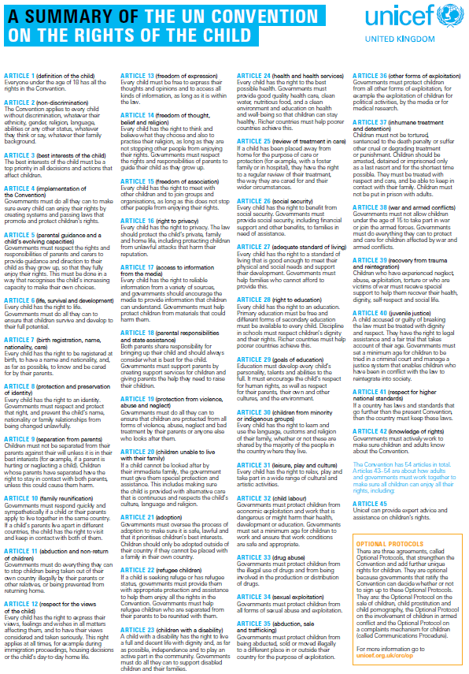

APPENDIX 2

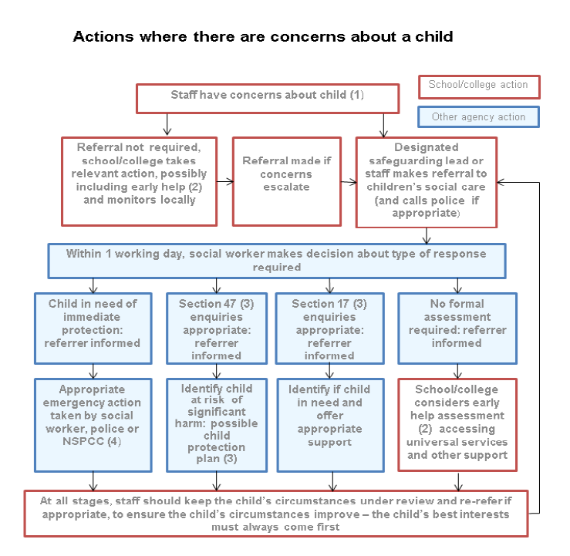

APPENDIX 3 - CAUSE FOR CONCERN FORM

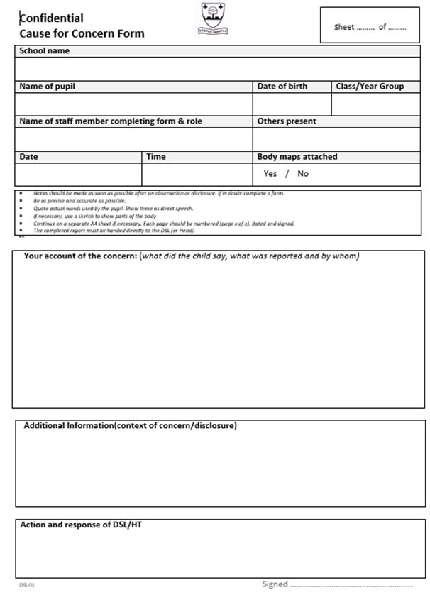

APPENDIX 4 – BODY MAP AND GUIDANCE (For use with APPENDIX 2)

Confidential
Body Map (to accompany completed ‘Cause for Concern’ form)

School name
Name of pupil |  | Class/Year Group
Name of staff member completing form
Date | Time

Body Map Guidance for Schools
- Body Maps should be used to document and illustrate visible signs of harm and physical injuries.
- Always use a black pen (never a pencil) and do not use correction fluid or any other eraser.

Do not remove clothing for the purpose of the examination unless the injury site is freely available because of treatment.
At no time should an individual teacher/member of staff or school be asked to or consider taking photographic evidence of any injuries or marks to a child’s person, this type of behaviour could lead to the staff member being taken into managing allegations procedures, the body map below should be used in accordance with recording guidance. Any concerns should be reported and recorded without delay to the appropriate safeguarding services, e.g. LADO or the child’s social worker if already an open case to social care.

When you notice an injury to a child, try to record the following information in respect of each mark identified e.g. red areas, swelling, bruising, cuts, lacerations and wounds, scalds and burns:

- Exact site of injury on the body, e.g. upper outer arm/left cheek.
- Size of injury - in appropriate centimetres or inches.
- Approximate shape of injury, e.g. round/square or straight line.
- Colour of injury - if more than one colour, say so.
- Is the skin broken?
- Is there any swelling at the site of the injury, or elsewhere?
- Is there a scab/any blistering/any bleeding?
- Is the injury clean or is there grit/fluff etc.?
- Is mobility restricted as a result of the injury?
- Does the site of the injury feel hot?
- Does the child feel hot?
- Does the child feel pain?
- Has the child’s body shape changed/are they holding themselves differently?

Importantly the date and time of the recording must be stated as well as the name and designation of the person making the record. Add any further comments as required.

Ensure First Aid is provided where required and record.

A copy of the Body Map should be kept on the child’s concern/confidential file, attached to the concern form.

DSL 02 Signed ………………………………………………..

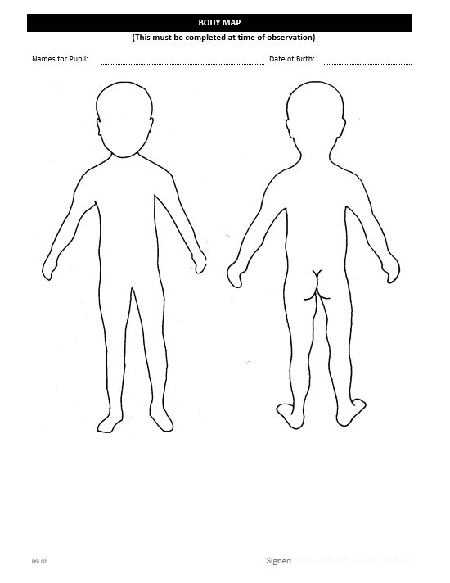

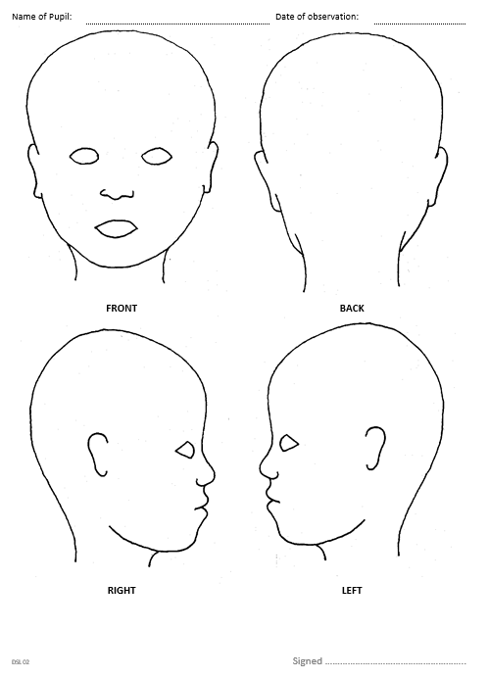

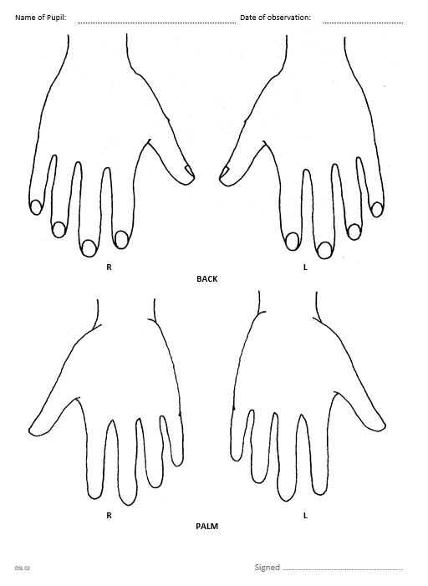

APPENDIX 5 – SAFEGUARDING LOG FILE

Elmwood Junior School
Confidential

Sheet ……... of ……...
Safeguarding File Log

This sheet should not be used to record disclosures and direct child protection information.
It is designed to record information from phone calls, meetings and discussions linked to child protection disclosures and concerns.

Name of child
Date and time
Person completing form
Event (e.g. meeting,
phone call, discussion etc)
Who involved

Include as much detail as possible

APPENDIX 6 – RECORD OF ACTIONS

Elmwood Junior School
Confidential

Sheet ……... of ……...
Record of Actions

Name of child
Date of birth

Date | Points of discussion | Actions

APPENDIX 7

TRANSFER OF SAFEGUARDING CHILD PROTECTION INFORMATION TO OTHER SCHOOLS

Elmwood Junior School
Confidential

Transfer of safeguarding child protection information

Information should only be passed to the named DSL or Headteacher at the receiving school.

Pupil name
Date of Birth

Sending school
Date

Receiving school
School name:

Address:

Phone no:

Headteacher:

Designated Safeguarding Lead:

Sent by | Received by
Name | Name
Role | Role
Signature | Signature
Date

APPENDIX 8 – LIST OF CONTACTS

Elmwood Junior School
‘We are committed to safeguarding and promoting the welfare of children and young people and expect all staff, volunteers and other third parties to share this commitment.’
The safety of our pupils is our number one priority. Any concerns or signs of abuse or neglect must be immediately reported to one of our Designated Safeguarding Leads (DSL).

Contact names
Designated Safeguarding Lead (DSL) | Mrs D Devecioglu Assistant Head Teacher
Deputy Designated Safeguarding Leads | Mrs A Read Head Teacher  Mr D Beck Deputy Head Teacher
Any other staff trained to DSL level | Mrs J Kriesler Assistant Head Teacher  Mrs H Henfrey Year Leader & ICT Coordinator  Mrs P Macleod Pupil Welfare and Data Manager
Head Teacher | Mrs A Read
Chair of Governors | Mr P Dancy
Named governor with responsibility  for safeguarding | Mr P Dancy

Local Authority (LA) contact
Our school follows the safeguarding protocols and procedures of our geographical local authority | Croydon Safeguarding Children Board (CSCB)
The Local Authority Designated Officer (LADO) for child protection | Steve Hall / Jane Parr  LADO@croydon.gov.uk  020 8255 2889  Bernard Weatherill House  6 Mint Walk  Croydon CRO 1EA
Local authority children’s social care referral team | 020 8726 6464 For advice
Local authority out of hours contact number | 020 8726 6000
Where there is a risk of immediate serious harm to a child, the police should be called and a referral made to children’s social care immediately. Anybody can make a referral.
Local Authority on line referrals MASH(Multi Agency Safeguarding Hub) then click on worried about a Croydon child
Or e-mail childreferrals@croydon.gov.uk
Local Police Emergency | 999
Local Police non-emergency | 101

National contacts
NSPCC Help Line | Tel: 0808 800 5000 Email: help@nspcc.org.uk
Child Line | Tel: 0800 11 11

Are you concerned
about a child?

If you are concerned about a child in our school:

Make a factual record of your concern.
(Include the date, time, the concern, other witnesses and your signature).

You should discuss any concerns with | Mrs D Devecioglu  Designated Safeguarding Lead Person
If the above person is unavailable, please talk to: | Mrs A Read Head Teacher  Mr D Beck Deputy Head Teacher  Mrs J Kriesler Assistant Head Teacher  Mrs H Henfrey Year Leader & ICT coordinator  Mrs P Macleod Pupil Welfare and Data Manager

Please share your concern straight away.

http://www.kidscape.org.uk/professionals/childabuse.shtml How to respond to an abuse disclosure is taken partly from the kidscape website.

